SQL
PROJECT
HOSPITALITY DOMAIN

1)Total Revenue:-
QUERY:-
SELECT SUM(revenue_realized) AS total_revenue
FROM fact_bookings;

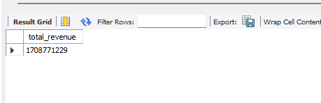

2)Total Bookings:-
QUERY:-
SELECT COUNT(booking_id) AS total_bookings
FROM fact_bookings;
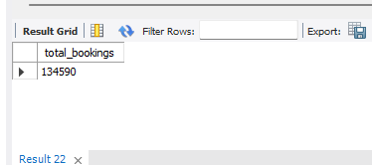

3)Total Capacity:-
QUERY:-
SELECT SUM(capacity) AS total_capacity
FROM fact_aggregated_bookings;
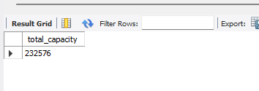
4)Total Successful Bookings:-
QUERY:-
SELECT SUM(successful_bookings) AS total_successful_bookings
FROM fact_aggregated_bookings;
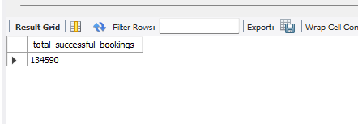
5)Occupancy Percentage:-
QUERY:-
SELECT
round(SUM(successful_bookings) / SUM(capacity),2) * 100 AS
occupancy_percentage
FROM fact_aggregated_bookings;
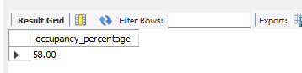

6) Average Rating:-
QUERY:-
SELECT
round( AVG(ratings_given) ,1)AS average_rating
FROM fact_bookings where ratings_given is not null and ratings_given >0;
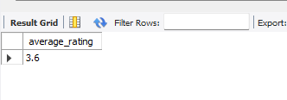
7 & 8)Total Cancellations and Cancellation Rate:-
QUERY:-
SELECT
COUNT(*) AS total_cancelled_bookings,
round(COUNT(*) * 100.0 / (SELECT COUNT(*) FROM fact_bookings)) AS cancellation_rate
FROM fact_bookings
WHERE booking_status = 'Cancelled';
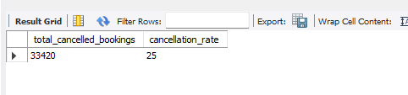

9 & 10)No Show Bookings and Rate:-
QUERY:-
SELECT
COUNT(*) AS total_no_show_bookings,
round(COUNT(*) * 100.0 / (SELECT COUNT(*) FROM fact_bookings)) AS no_show_rate
FROM fact_bookings
WHERE booking_status = 'No show';
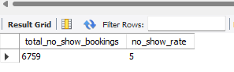
11) Revenue by City:-
QUERY:-
SELECT h.city,
SUM(b.revenue_realized) AS revenue_by_city
FROM fact_bookings b
JOIN dim_hotels h ON b.property_id = h.property_id
GROUP BY h.city;
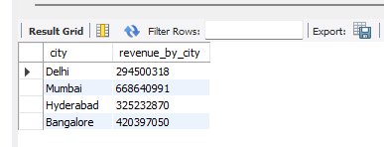

12) Occupancy % by City:-
QUERY:-
SELECT h.city,SUM(ab.successful_bookings) / SUM(ab.capacity) * 100 AS occupancy_by_city
FROM fact_aggregated_bookings ab
JOIN dim_hotels h ON ab.property_id = h.property_id
GROUP BY h.city;
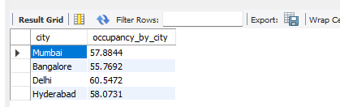
13) Average Rating by City:-
QUERY:-
SELECT h.city,round(AVG(b.ratings_given)) AS avg_rating_by_city
FROM fact_bookings b
JOIN dim_hotels h ON b.property_id = h.property_id
where b.ratings_given is not null and ratings_given>0
GROUP BY h.city;
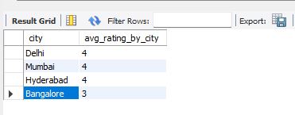

14) Weekly Trend of Occupancy % and Average Rating:-
QUERY:-
- OCCUPANCY PERCENTAGE
SELECT dim_date.`week no`,round(SUM(ab.successful_bookings) / SUM(ab.capacity) * 100,1) AS weekly_occupancy_percentage
FROM fact_aggregated_bookings ab
JOIN dim_date ON ab.check_in_date = dim_date.date
GROUP BY dim_date.`week no`
ORDER BY dim_date.`week no`;

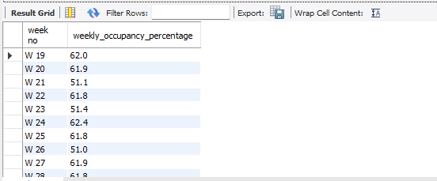

- AVGERAGE RATING
alter table fact_bookings
modify column check_in_date date;
alter table dim_date
add column `datee` date ;
update dim_date
set datee=str_to_date(`date`,"%d-%M-%y");
SELECT
dim_date.`week no`,
round(AVG(b.ratings_given),1) AS weekly_avg_rating
FROM fact_bookings b
JOIN dim_date ON b.check_in_date = dim_date.`datee`
GROUP BY dim_date.`week no`
order by dim_date.`week no`;
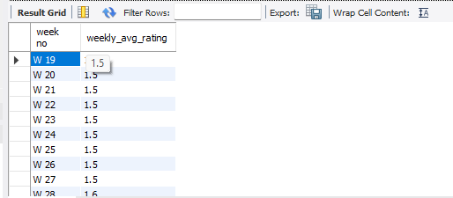
14) Occupancy by Day Type (Weekday vs Weekend):-
QUERY:-
SELECT
dim_date.day_type,
round(SUM(fact_aggregated_bookings.successful_bookings) / SUM(fact_aggregated_bookings.capacity) * 100) AS occupancy_by_day_type
FROM fact_aggregated_bookings
JOIN dim_date ON fact_aggregated_bookings.check_in_date = dim_date.`date`
GROUP BY dim_date.day_type;
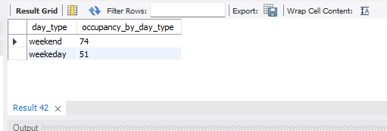
15) Booking % by Platform:-
QUERY:-
SELECT fact_bookings.booking_platfrom,
round(COUNT(*) * 100.0 / (SELECT COUNT(*) FROM fact_bookings),1) AS booking_percentage
FROM fact_bookings
GROUP BY fact_bookings.booking_platfrom;

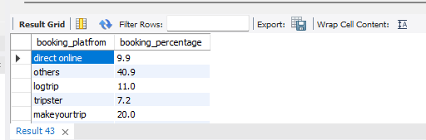
16) Split of booking % by platforms:-
QUERY:-
/*SELECT h.city,
COUNT(*) * 100.0 / (SELECT COUNT(*) FROM fact_bookings WHERE property_id = h.property_id) AS cancellation_percentage
FROM fact_bookings b
JOIN dim_hotels h ON b.property_id = h.property_id
WHERE b.booking_status = 'Cancelled'
GROUP BY h.city;*/
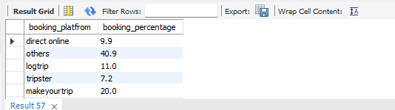
17) Citywise Cancellation %:-
QUERY:-
WITH total_bookings_by_property AS (
SELECT property_id, COUNT(*) AS total_bookings
FROM fact_bookings
GROUP BY property_id
)

SELECT
h.city,
h.property_name,
COUNT(*) * 100.0 / tb.total_bookings AS cancellation_percentage
FROM fact_bookings b
JOIN dim_hotels h ON b.property_id = h.property_id
JOIN total_bookings_by_property tb ON b.property_id = tb.property_id
WHERE b.booking_status = 'Cancelled'
GROUP BY h.city, h.property_name, tb.total_bookings;

WITH total_bookings_by_city AS (
SELECT
h.city,

COUNT(*) AS total_bookings
FROM fact_bookings b
JOIN dim_hotels h ON b.property_id = h.property_id
GROUP BY h.city
)

SELECT
h.city,
COUNT(*) * 100.0 / tb.total_bookings AS cancellation_percentage
FROM fact_bookings b
JOIN dim_hotels h ON b.property_id = h.property_id
JOIN total_bookings_by_city tb ON h.city = tb.city
WHERE b.booking_status = 'Cancelled'
GROUP BY h.city;

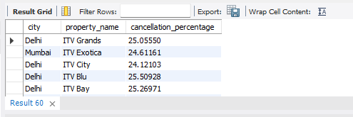
18) Popular Room Types by Number of Bookings:-
QUERY:-
SELECT r.room_class,COUNT(*) AS bookings_by_room_class
FROM fact_bookings b
JOIN dim_rooms r ON b.room_category = r.room_id
GROUP BY r.room_class
ORDER BY bookings_by_room_class DESC;
